I read the article:

**5G-Smart Diabetes: Toward Personalized Diabetes Diagnosis with Healthcare Big Data Clouds**

* Goal of research:

to design a sustainable, cost-effective, and intelligent diabetes diagnosis solution with personalized treatment.

* In this article:

they first propose the 5G-Smart Diabetes system, which combines technologies such as wearables, machine learning, and big data to generate comprehensive sensing and analysis for patients suffering from diabetes.

Then they present the data sharing mechanism and personalized data analysis model for 5G-Smart Diabetes.

Finally, they build a 5G-Smart Diabetes testbed that includes smart clothing, smartphone, and big data clouds.

* Results: The experimental results show that the system can effectively provide personalized diagnosis and treatment suggestions to patients.
* the “5G” in 5G-Smart Diabetes has two meanings:

One: it refers to the 5G technology that will be adopted as the communication infrastructure to realize high-quality and continuous monitoring of the physiological states of patients with diabetes and to provide treatment services for such patients without restraining their freedom.

Two: “5G” refers to the following “5 goals”: cost effectiveness, comfortability, personalization, sustainability, and smartness

* History of diabetes treatment:

Diabetes 1.0:

Hospitalization and glucose monitoring

Diabetes 2.0:

Out of hospital smart wearables for glucose and physiological monitoring. Wearable costs around $10000.

Check table 1 for more comparison details between the new and old treatment methods.

Table 1: comparison between the different diabetes treatment methods

|  |  |  |  |  |  |  |
| --- | --- | --- | --- | --- | --- | --- |
| Solution | cost | Comforta-bility | Network support | Personali-zation | Sustainabl-ilty | Treatment pattern |
| Diabetes 1.0 | High | Low | n/a | Low | Low | Hospitalization, manual measurements, manual injections |
| Diabetes 2.0 | Medium | Medium | Social network | High | Low | Automatic and smart blood glucose sensing devices, contrasting analysis of drug effects, beta cell restoration, beta cell preservation |
| 5G- Smart Diabetes | low | high | 5G network, big data networks, social networks | high | high | User-oriented data fusion, treatment intelligence via data analystics |

* 5G-Smart Diabetes Architecture:

Comprised of three layers as shown in Figure 1:

Sensing layer, personalized diagnosis layer, and data sharing layer.

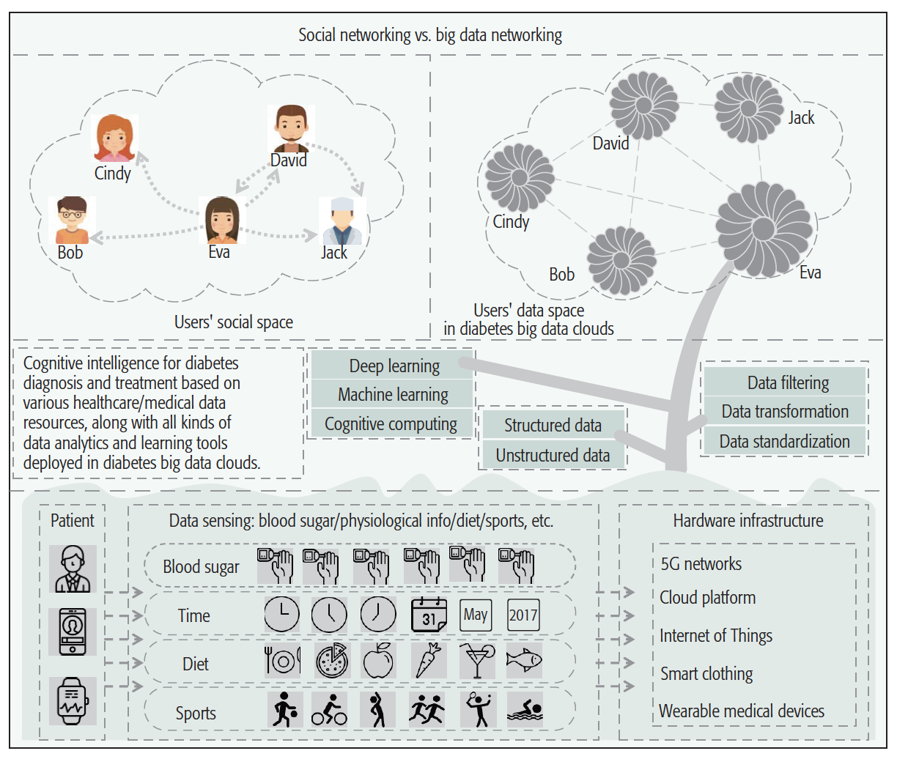

FIGURE 1: 5G-Smart System Architecture

* Data sharing and personalized analysis model for 5G-Smart Diabetes:

the data sharing and personalized diabetes treatment of 5G-Smart Diabetes. As shown in Fig. 2, the 5G-Smart Diabetes system first integrates the 5G network, social network, and big data network to discover the interconnection between social relationship and physical data location at clouds, facilitating data sharing with joint social space and data space. Then, based on machine learning and cognitive computing, the 5G-Smart Diabetes system can get an intelligent diagnosis by analyzing multidimensional big data related to diabetes to provide personalized diabetes diagnostic services to patients.

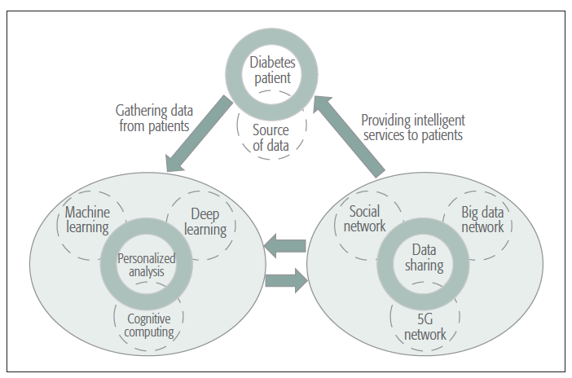

FIGURE 2: Data sharing and personalized analysis model for 5G-Smart Diabetes

* Personalized data analysis model for 5G-Smart Diabetes:

The establishment of the personalized data analysis model for 5G-Smart Diabetes is based on the data, which includes

public data and

personalized data.

Typically, the public data come from hospital diabetes big datasets with the removal of users’ privacy and sensitive information. The personalized data make up a user’s personal dataset.

In this research, they first use public data to train a public diabetes diagnosis model. Then they can obtain a personalized data analysis model based on the public diabetes diagnosis model and personalized data.

* The specific process is as follows:

They first obtain the dataset of in-hospital diabetes patients (i.e., users’ electronic medical records, EMRs). The EMR data include structured data and unstructured data. For the structured data, according to the doctor’s advice, they select features associated with diabetes. For the unstructured data, which include text and image data, they use a convolutional neural network (CNN) [13, 14] to select a feature. Then they use feature fusion and a deep learning algorithm for data analytics in order to obtain a public diabetes diagnosis model.

Through this model, they can get the users’ risk assessment of diabetes. Then they establish a personalized data analysis model based on the multi-source and multi-dimension data. The personalized data includes user daily life data (i.e., working, sleeping, physical exercise and food intake) collected by smartphone and wearable 2.0, and the blood glucose index collected by medical devices. All this information is sent to the healthcare big data cloud. In the cloud, they first use the public diabetes model and transfer learning to label the risk assessment of diabetes. Then, based on the blood glucose index collected by the medical devices, the label is verified for its correction. When they obtain the ground-truth diabetes risk assessment label, they re-train the personalized data to get a stronger personalized data analysis model. Based on the personalized data analysis model, the 5G-Smart Diabetes system can get a more concrete and targeted personalized risk assessment and therapeutic schedule, which can provide detailed daily advice to guide a patient to improve the self-treatment of diabetes.

* The testbed of machine learning algorithms:

3 machine learning algorithms are used:

Decision tree

Sup-port vector machine

Artificial neural network

The ensemble method is used conduct integration of models

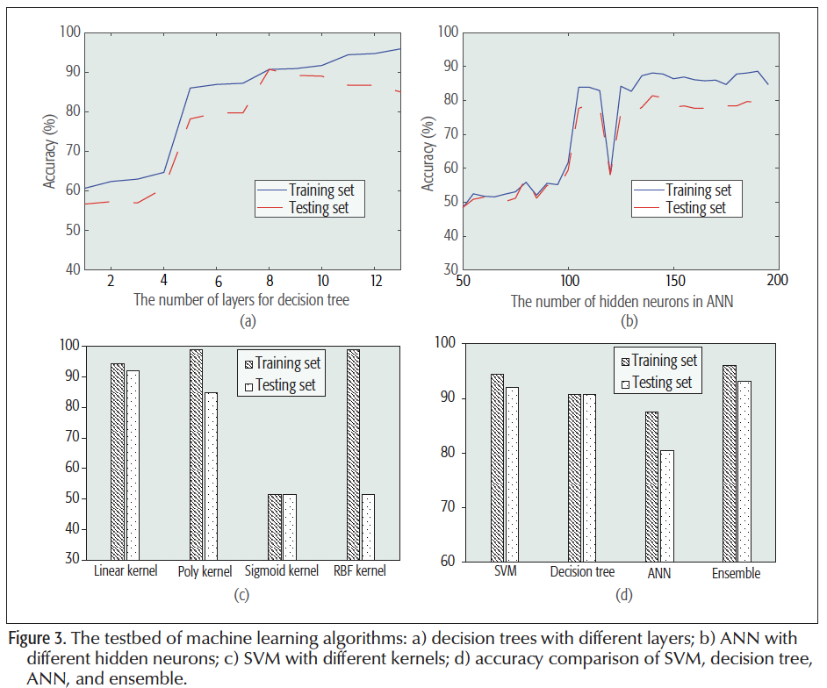

* Suggestions on prevention and treatment of diabetes:

Diet suggestions, sport suggestion, and data sharing in a social network for motivation purposes.

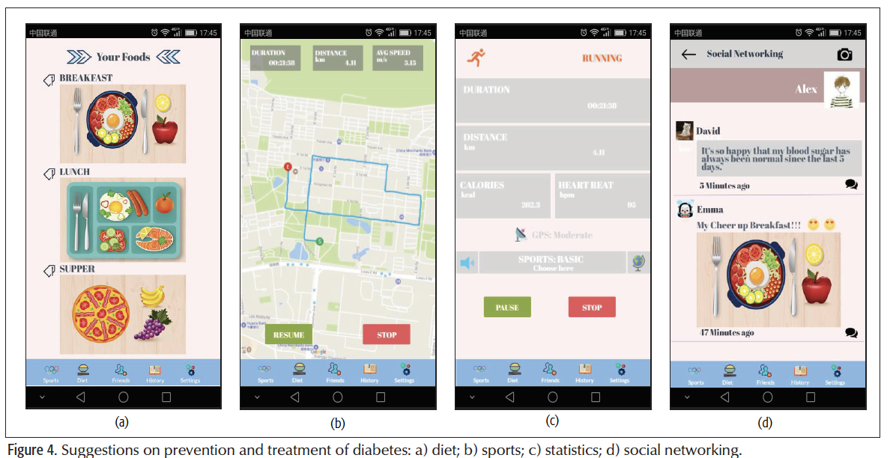

Conclusion:

They proposed the system, developed it and tested its validity. It works well!

Article:

<https://journals-scholarsportal-info.proxy.library.carleton.ca/pdf/01636804/v56i0004/16_5dtpddwhbdc.xml>